READING TWO COMIC STRIPS TO MAKE THE STORIES COHERENT

AUTHOR: Bruno Mello Ferreira - brunomeferreira@gmail.com

Observe the comic strips below. The sequence of the events is not correct. Organize them correctly.

Comic strip 1

( ) ( ) ( ) ( )
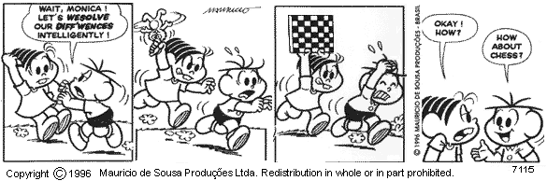
http://inglesearte.blogspot.com.br/2010/03/comic-strips.html

Comic strip 2

( ) ( ) ( ) ( )
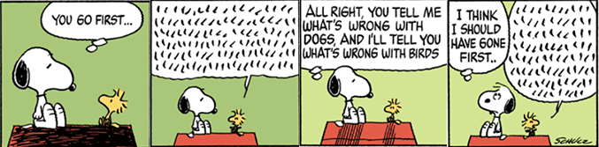
http://inglesearte.blogspot.com.br/2010/03/comic-strips.html

