LISTENING TO A STORY TO REARRANGE THE EVENTS OF A COMIC STRIP

AUTHORS: Rosely Perez Xavier – t4tenglish@gmail.com
Bruno Mello Ferreira - brunomeferreira@gmail.com

The sequence of the events below is not correct. Listen to the story and organize the events correctly. Use numbers from 1 to 7 in the parentheses. Note: There are events that do not correspond to the story.

THE FLINTSTONES (Bill Hanna & Joe Barbera)

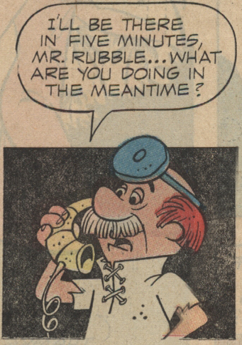
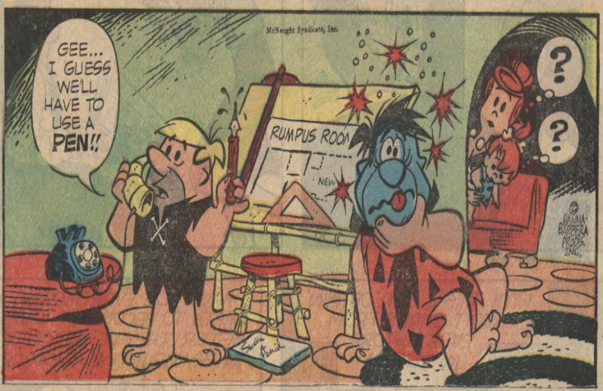
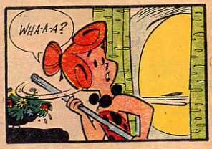
( ) ( ) ( )
https://comicrazys.files.wordpress.com/2009/10/flintstones_sundays_0021.jpg
https://www.pinterest.com/pin/465348573968954516/


     

