**READING A NARRATIVE TO LOCATE INCONSISTENCIES**

**AUTHORS**: Rosely Perez Xavier – [t4tenglish@gmail.com](mailto:t4tenglish@gmail.com)

Bruno Mello Ferreira - [brunomeferreira@gmail.com](mailto:brunomeferreira@gmail.com)

The narrative below contains parts that **do not** correspond to the story of *The Flintstones* comic strip. Underline the parts and give the correct information in English.

**NARRATIVE:** Fred is working when his friend comes in. Fred’s friend congratulates him and Fred swallows the pencil. Fred can’t speak, and his friend gets a syringe so Fred can speak. Fred’s friend calls the teacher. The teacher says he is coming in fifteen minutes. Fred’s friend decides to use a chalk to help him. Fred’s friend decides to use a chalk.

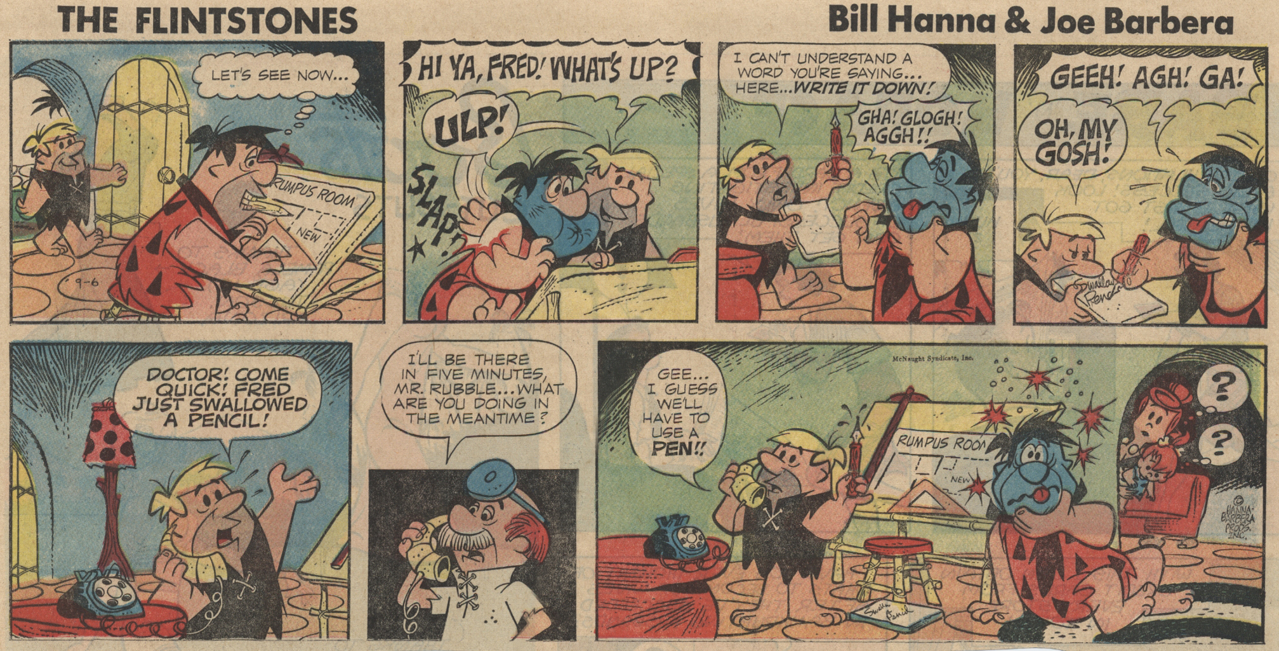

https://comicrazys.files.wordpress.com/2009/10/flintstones_sundays_0021.jpg