Relating narratives to the events of a comic strip,
and giving a title to the story

AUTHOR: Rosely Perez Xavier – t4tenglish@gmail.com

Identify the best narrative for each picture below. Use the options provided. At the end, give a title in English to the story.

a) Oh Oh. He looks at us.
b) Yogi Bear invents a balloon-o-copter and it works.
c) Finally, the last balloon breaks.
d) Oh, wait. It doesn’t work. Yogi Bear looks up at the balloons.
e) Yogi Bear falls down.
f) One balloon breaks.

Title: ________________________________________________________________

1. ( )  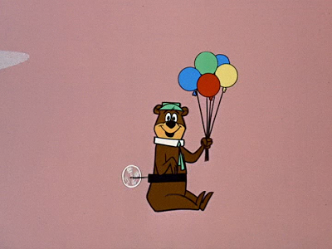 | 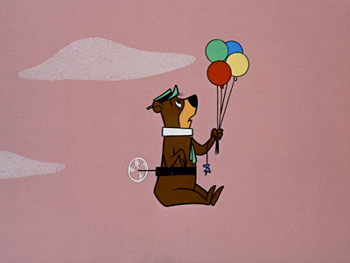  2. ( )
3. ( )  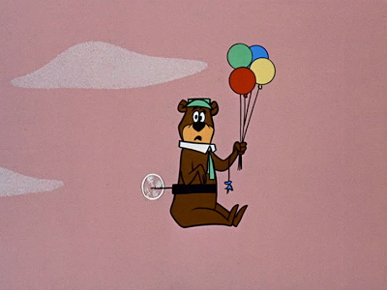 | 4. ( )  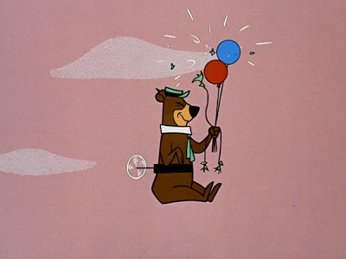
5. ( ) | 6. ( )  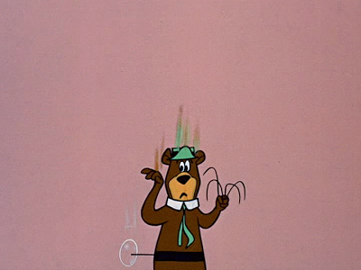
http://yowpyowp.blogspot.com/2014_03_01_archive.html

