Creating a story FOR a comic strip

AUTHOR: Rosely Perez Xavier – t4tenglish@gmail.com

Write in English the speech balloons o create a comic strip.

1. 2.
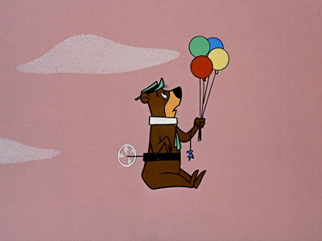

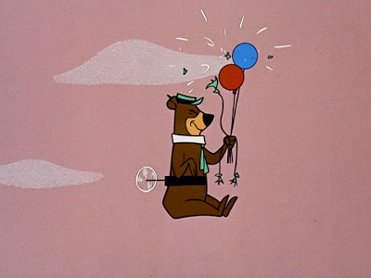
3. 4.

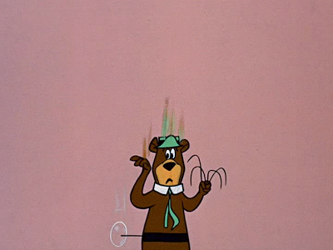
5. 6.

http://yowpyowp.blogspot.com/2014_03_01_archive.html

