Reading the fable ‘The bear and the two friends’
to understand specific information

AUTHORS: Ana Maria Noronha - ananoronhaa@gmail.com
Rosely Perez Xavier – t4tenglish@gmail.com.br

Read the fable below and answer the questions in Portuguese.

The bear and the two friends
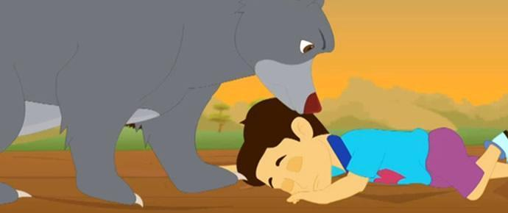

Two friends were walking through the forest. They knew that the forest was dangerous. So they promised each other that they would remain united in any case of danger.
Suddenly, they saw a large bear approaching them. One of the friends quickly climbed a tree. But the other did not know how to climb. So he lay down on the ground, pretending to be a dead man.
The bear smelt in his ears, and slowly left the place. The friend on the tree came down and asked his friend on the ground, “Friend, what did the bear tell you into your ears?” The other friend replied, “The bear advised me not to believe a false friend.

Moral: A true friend always supports and stands by you in any situation.

Submitted by: Abdul Rafay Katapr Larkana Sindh, Pakistan

Adapted from http://www.moralstories.org/the-bear-and-the-two-friends/

a) Onde se passa a estória?

b) Quem são os personagens?

c) Qual é a promessa que os personagens fazem um ao outro?

d) O que fez cada personagem quando o animal apareceu diante deles?

e) O que o animal fez para um dos personagens?

f) O que um dos personagens perguntou para o outro? E qual foi a sua resposta?

g) Qual é a moral da estória?

