Contrasting two versions of the fable ‘THE BEAR AND THE TWO FRIENDS’;
choosing the favorite and justifying

AUTHORS: Ana Maria Noronha - ananoronhaa@gmail.com
Rosely Perez Xavier – t4tenglish@gmail.com.br

The story you read in Activity 1 is a modern version of the fable The Bear and the Two Travelers. Read the traditional version below and give three differences between the modern version and the traditional version of the fable. Answer in English using the table provided.

The Bear and the Two Travelers

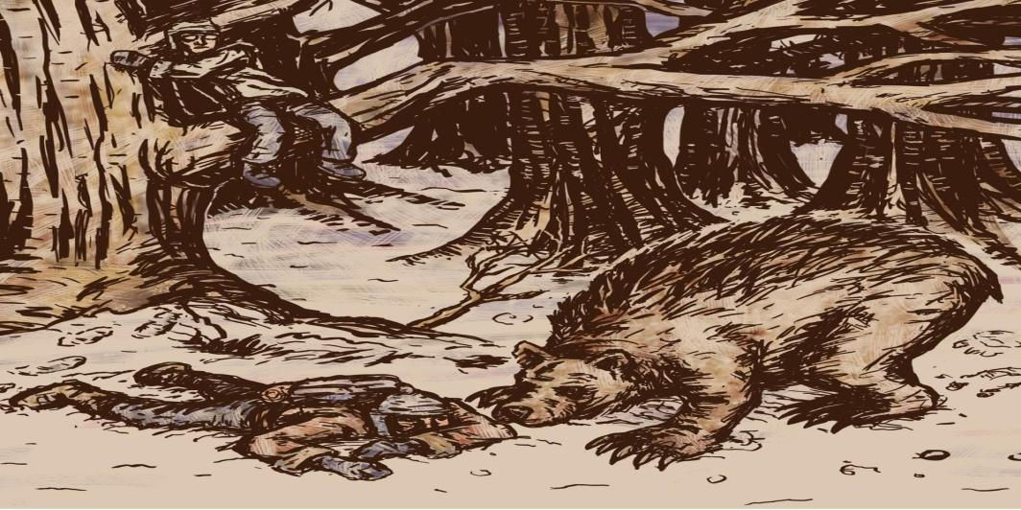
http://paulotteson.bandcamp.com/track/the-bear-and-the-two-travelers
Two men were traveling together, when a Bear approached them.

One of the men climbed up quickly into a tree. The other, feeling that he would be attacked, fell flat on the ground.

The Bear came up and smelt him all over. He pretended to be dead. The Bear soon left him.

The other traveler came down out of the tree and asked his friend, "What did the Bear whisper in your ear?"

His companion replied, "He gave me this advice: Never travel with a friend who deserts you at the approach of danger."

Moral: Misfortune tests the sincerity of friends.

Author: Aesop
Adapted from http://www.bedtime.com/html/the_bear_and_the_two_travelers.htm

DIFFERENCES

Modern version | Traditional version
1. In this version _______________________  _____________________________________  _____________________________________  2. In this version _______________________  _____________________________________  _____________________________________  3. In this version _______________________  _____________________________________  _____________________________________ | 1. In this version _______________________  _____________________________________  _____________________________________  2. In this version _______________________  _____________________________________  _____________________________________  3. In this version _______________________  _____________________________________  _____________________________________

Which version of the fable did you like most? Read the versions again to decide. Justify your answer in English.

