COMPARING THE FABLES ‘THE LION GOING TO WAR’
AND ‘THE FOX AND THE GRAPES’

AUTHORS: Ana Maria Noronha - ananoronhaa@gmail.com
Rosely Perez Xavier – t4tenglish@gmail.com.br

Read the fables below and complete the table provided. Write your answers in English.

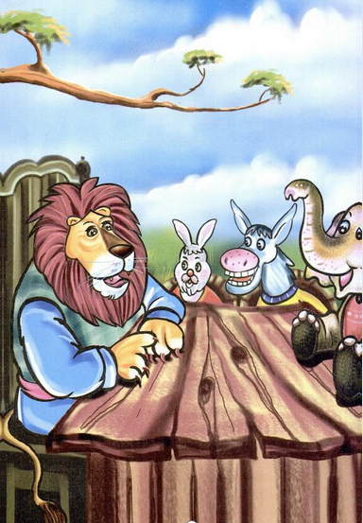
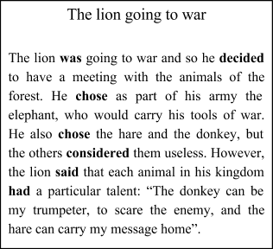
Fable 1
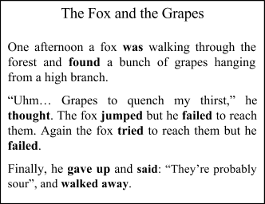
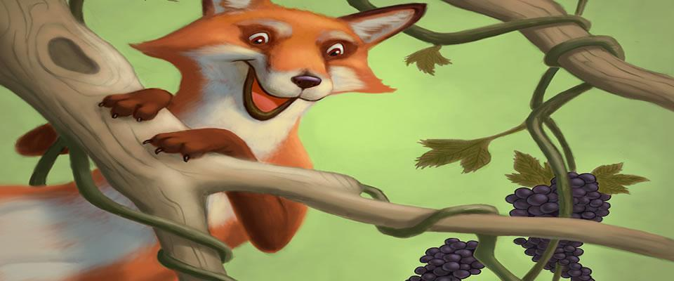
Fable 2

Adapted from http://www.moralstories.org/the-fox-and-the-grapes/

 | The lion going to war | The fox and the grapes
a) Personagens:

b) Local onde a história acontece:

c) Objetivo do personagem principal:

d) Problema que o personagem principal enfrentou:

e) Solução que o personagem deu ao problema:

