Creating a bilingual mini-dictionary
WITH ENHANCED past verbs FOUND IN THE FABLES

AUTHORS: Ana Maria Noronha - ananoronhaa@gmail.com
Rosely Perez Xavier – t4tenglish@gmail.com.br

Elaborate a bilingual mini-dictionary with the verbs in bold found in the fables you read. List the verbs in alphabetical order, and follow the model below.

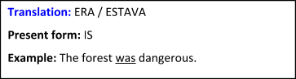
WAS
(past form)

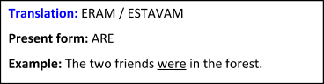
WERE
(past form)

