UNSCRAMBLING THE FABLE ‘The Hare and the Tortoise’
TO MAKE IT COHERENT

AUTHOR: Ana Maria Noronha - ananoronhaa@gmail.com

The text below refers to the fable The hare and the tortoise, but the text is disorganized. Use numbers to indicate the correct sequence of the story. Number 1 is given to you.

The Hare and the Tortoise
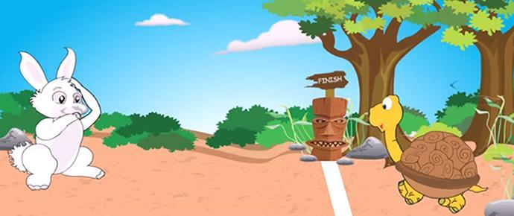

a) ( ) He then decided to stop and relax before continuing the race. He sat under a tree and fell asleep.

b) ( 1 ) One day a hare and a tortoise argued about who was faster.

c) ( ) The hare woke up and realized that he had lost the race.

d) ( ) They decided to compete in a race.

e) ( ) The tortoise walked step by step and soon finished the race.

f) ( ) Moral: Never underestimate the weakest opponent.

g) ( ) The hare raced way ahead of the tortoise. At the half-way point, the hare could not see the tortoise.

