**READING TWO SYNOPSES**

**TO UNDERSTAND SPECIFIC INFORMATION**

**AUTHORS**: Aline Boehs - [**alineboehs@gmail.com**](mailto:alineboehs@gmail.com)

Felipe Frazão Gevieski - [felipegevieski@gmail.com](mailto:felipegevieski@gmail.com)

Rosely Perez Xavier – [t4tenglish@gmail.com.br](mailto:t4tenglish@gmail.com.br)

Complete the table in Portuguese according to the movie synopses provided.

|  |  |  |
| --- | --- | --- |
|  | **MOVIE 1** | **MOVIE 2** |
| Nome do filme  (em inglês) |  |  |
| Data de lançamento |  |  |
| Gênero do filme |  |  |
| Diretor |  |  |
| Faturamento na primeira semana |  |  |
| Resumo da história |  |  |

**Movie 1**

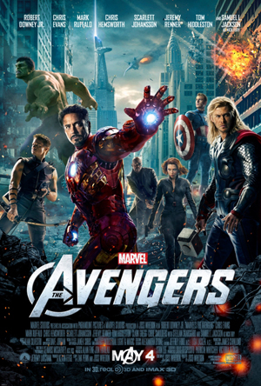The Avengers is a 2012 American superhero action movie written and directed by Joss Whedon. It is based on Marvel Comics characters. The movie is distributed under Walt Disney Pictures and it was premiered on April 11, 2012. Released in North America on May 4, 2012. It stars Robert Downey Jr., Chris Evans, Mark Ruffalo, Chris Hemsworth, Scarlett Johansson, Jeremy Renner,Tom Hiddleston and Samuel L. Jackson. The movie tells the story of a group of heroes, such as the Hulk, Captain America, Iron Man and Thor, who gather to fight an alien threat. The film received positive reviews from most film critics. It set numerous box office records, including the biggest opening weekend in North America, and tied the record for the fastest film to gross $1 billion worldwide.

<http://en.wikipedia.org/wiki/The_Avengers_(2012_film)>

**MOVIE 2**

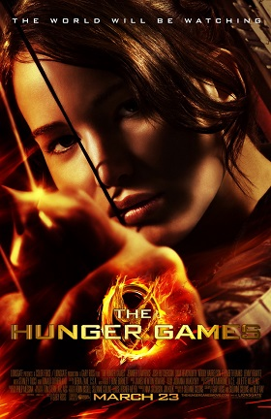The Hunger Games is a 2012 American science fiction action film directed by Gary Ross, and based on the novel of the same name by Suzanne Collins. The film was produced by Nina Jacobson and Jon Kilik, with a screenplay by Ross, Collins, and Billy Ray. It stars Jennifer Lawrence, Josh Hutcherson, Liam Hemsworth, Woody Harrelson, Elizabeth Banks, and Donald Sutherland. The movie tells the story of a girl who has to compete in a game with twelve people, where only one person wins, and the competitors fight for their lives. The film was released on March 23, 2012. The film's opening weekend gross ($152.5 million) is the fourth largest of any movie in North America. It is the first film since Avatar to remain in first place at the box office for four consecutive weekends.

<http://en.wikipedia.org/wiki/The_Hunger_Games_(film)>