COMPLETING ANOTHER REVIEW WITH LINKING WORDS

AUTHORS: Natália Alves - alves_tatai@hotmail.com
Rosely Perez Xavier – t4tenglish@gmail.com.br

The text below is a review of the movie A Thousand Words. The text is incomplete. Watch a scene of the movie and complete the review in English.

A Thousand Words
Review
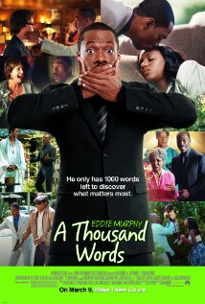
This is a hilarious comedy movie for kids and adults.

The story is about Jack McCall (Eddie Murphy), a literary agent who is not completely honest. When trying to do business with the guru named Dr. Sinja, Jack sees a magical tree in his yard. According to Dr. Sinja, the tree and Jack are connected. Every time Jack says a word, a leaf falls from the tree. When the last leaf drops, Jack will die. Jack learns a lesson at the end.

The scene I liked most happens at a cafeteria. The attendant asks what the man wants to eat and drink, but ⁽¹⁾ _______________
________________________________________________. The attendant tries to guess what the man is saying, but ⁽²⁾ ___________________________________
_____________________________________________________________________. At the end, the attendant understands what the man wants when ⁽³⁾ __________________________________
___________________________________ . The man wants some coffee with three shots of milk.

I loved the story. I give it a 9.
- Written by Rosely and Natália

