WRITING SPEECH BALLOONS TO CREATE A STORY
BASED ON THE FABLE ‘THE FOX AND THE GRAPES’

AUTHORS: Ana Maria Noronha - ananoronhaa@gmail.com
Rosely Perez Xavier – t4tenglish@gmail.com.br

The pictures below refer to the fable The fox and the grapes. Write, in English, the speech balloons to reproduce the story.

- 2. 2.
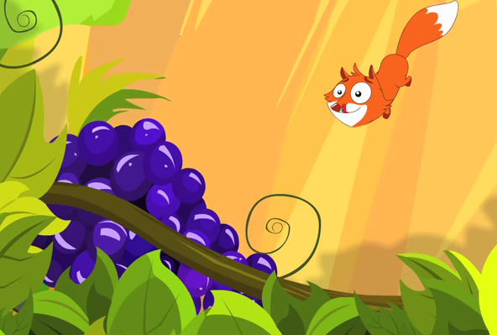
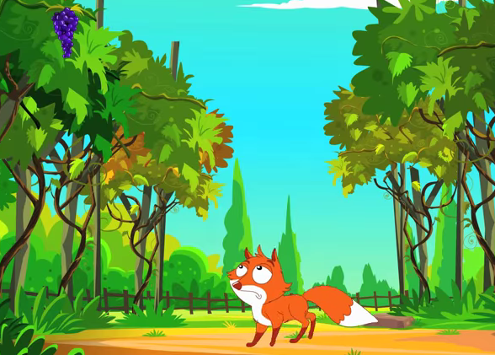

3. 4. 4.
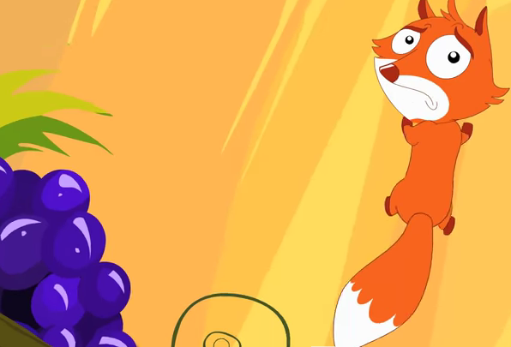
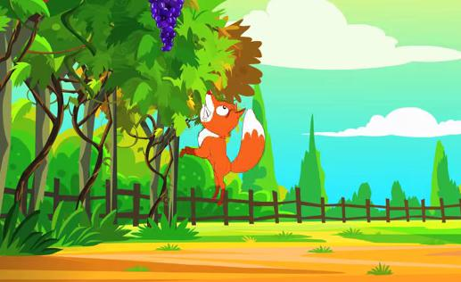

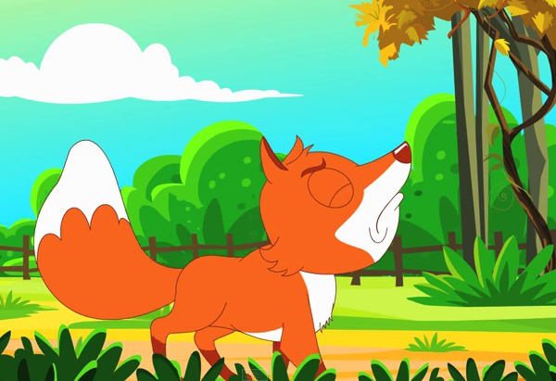
5.

